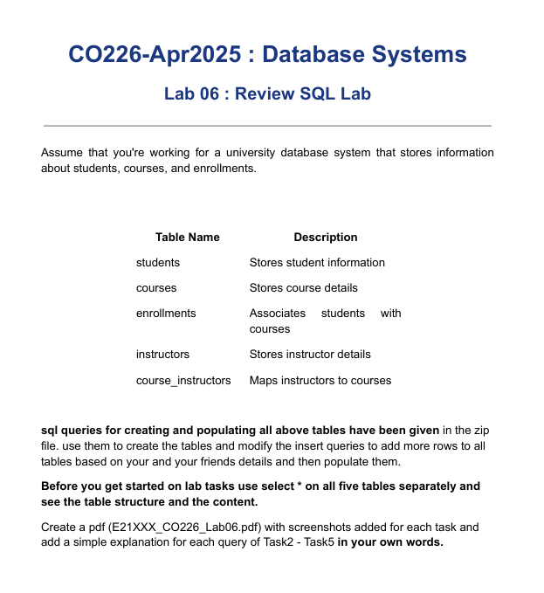
CO226 – DATABASE SYSTEMS LAB 06
S.K.A.K. Madhushan
E/21/245

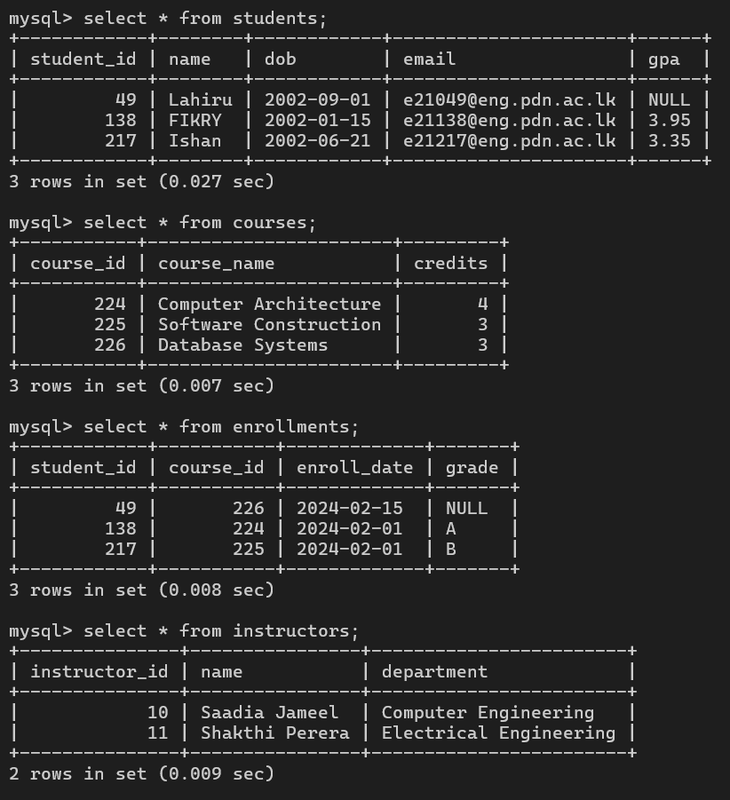

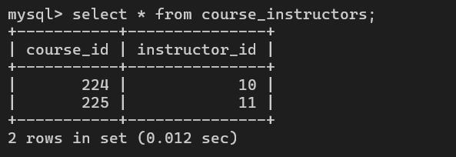

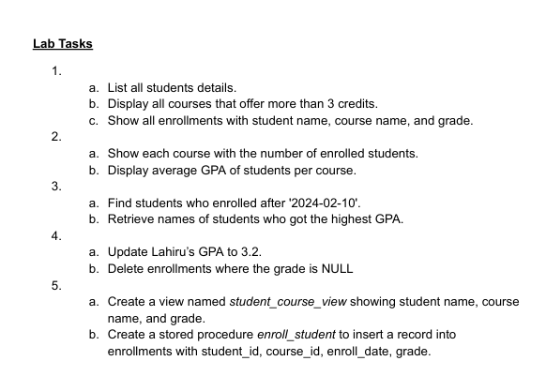

- a.
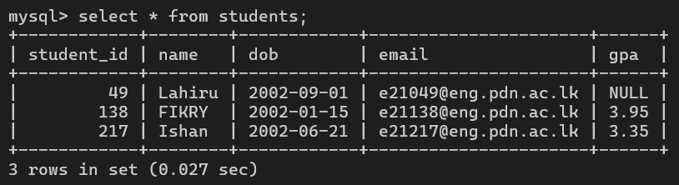

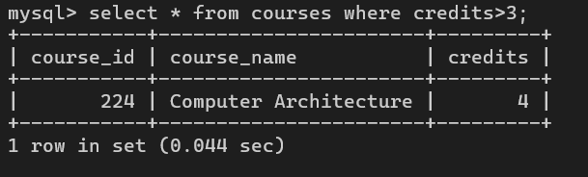
b.

c.
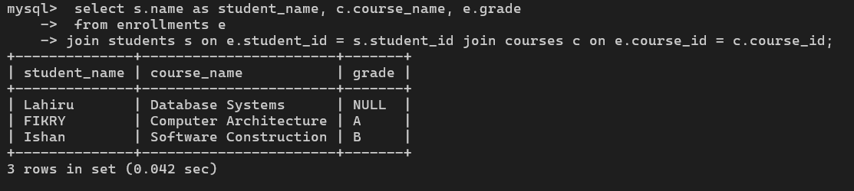


a.
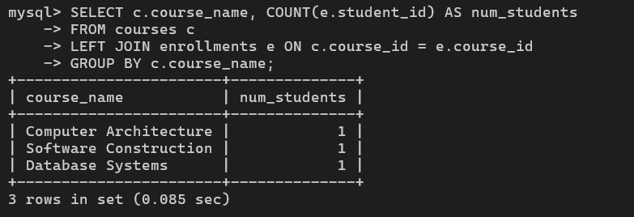

We are selecting the course name and counting how many students are in each course,
We match each course with enrollments using the course ID. Even if no one enrolled, the course still shows up because it's a LEFT JOIN.We group the results course-by-course.


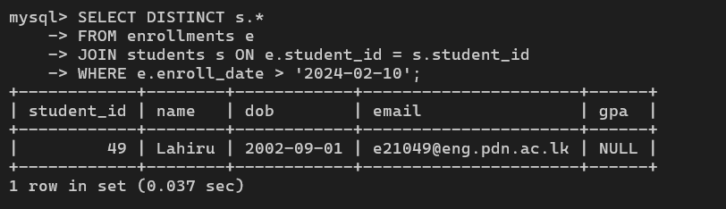

In here we are selecting all student details but only unique ones. Start from enrollments to find when students joined and Match enrollment records to student info only pick students who enrolled after Feb 10.
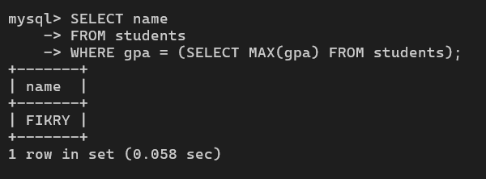
b.
We just want the name of the highest gpa person and for that here we are create a sub query to find it , we use MAX() to find highest GPA from the all students and next we get that highest GPA and find the person who has that .


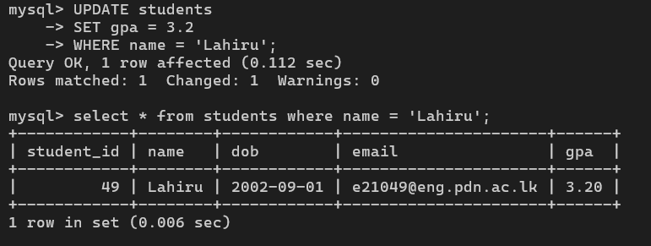

in here we are updating the Lahiru’ s gpa with the value 3.2 which was before NULL
and here we just simply use the UPDATE , SET commands to do that
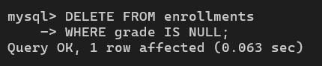

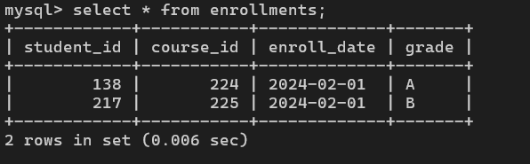

simply used DELETE keyword to delete the person who has NULL grade and you can see then the row has deleted .

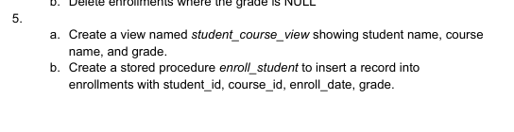

a.
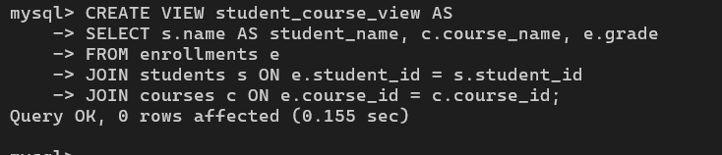

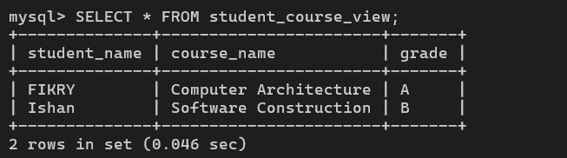

We want to make a VIEW which is a like new virtual table without store data (in here it is called as student_course_view) , for that we are start with enrollments (where all the connections are in ) and we Connect to the students table for names and Connect to the courses table for course names.
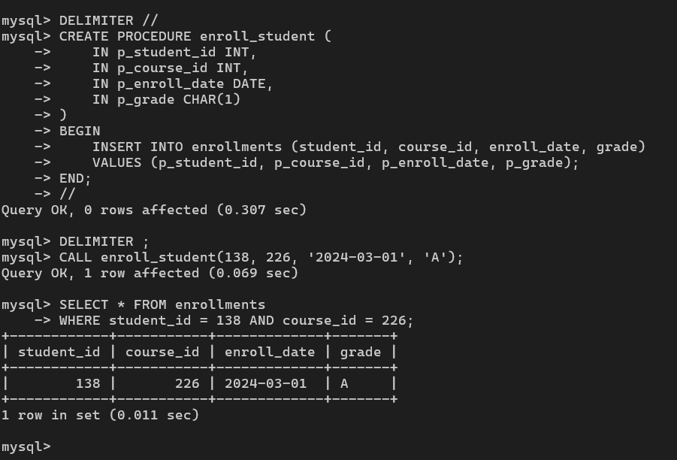
b.

In this task we are making a reusable command (procedure) called enroll_student with input parameters.These are the inputs we’ll give the procedure (student ID, course ID, date, grade).Then we give what to do when this procedure run ,in BEGIN and END block.take the inputs and stick them into the enrollments table.

